**Practical 4**

**Preparing straight and cross cables**

**Straight-Through Wired Cables**

Straight-Through refers to cables that have the pin assignments on each end of the cable. In other words Pin 1 connector A goes to Pin 1 on connector B, Pin 2 to Pin 2 etc. Straight-Through wired cables are most commonly used to connect a host to client. When we talk about cat5e patch cables, the Straight-Through wired cat5e patch cable is used to connect computers, printers and other network client devices to the router switch or hub (the host device in this instance).

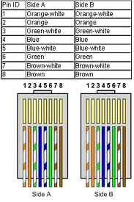

**Crossover Wired Cables**

An Ethernet crossover cable is a type of Ethernet cable used to connect computing devices together directly. Normal straight through or patch cables were used to connect from a host network interface controller (a computer or similar device) to a network switch, hub or router. A cable with connections that "cross over" was used to connect two devices of the same type: two hosts or two switches to each other.

